Professional Triathlete Heleen bij de Vaate
Season 2012

“Dutch Champion Long Distance!”

Dear Reader,

This season I had some great results. For the third time I became Dutch Champion long distance triathlon in Almere and I finished 2x on the podium in an Ironman race. Unfortunately I had some setbacks as well, or was just unlucky. I would like to review this season with you below:

January-March 70.3 IronMan South-Africa and trainingcamps
In January I went to South-Africa for two weeks. I participated in the 70.3 Ironman and did a small block of training in the sun. The training during the winter months went well, so I had a good basis. But the week before I left, I got a stomach virus. Luckily it was over when I arrived in South-Africa, but it might have affected my fitness. The race was a little bit disappointing. I lost allmost 15 minutes during the swim due to the rough sea. I was swimming all by myself and could hardly see the buoys. Also during the bike part I didn’t feel strong. The second part of the run I got the spirit back and past three other girls. The result was a 7th place. After South-Africa I trained at home for one month. In the beginning of March I went to Lanzarote for two weeks. This was a very good camp where I did some hard training sessions to prepare for the summer race season.

April-May Half Challenge Fuerteventura and IronMan Lanzarote
These two months were characterized by racing on the Canary Islands. The first race took place in April on Fuerteventura. This is quite a though race with a lot of elevation during the bike as well as during the run. But it was a nice and fair race. I did this race as a hard training session for IM Lanzarote. An 8th spot was the result. After the race I had one more week on this beautiful island to prepare myself for the first peak of the season: IM Lanzarote. In this week I did some long rides with a hard wind of 5/6 Bft. These rides have made me certainly stronger. Five weeks after the race on Fuerteventura I started in the Ironman of Lanzarote. I was excited to race and it seemed to be a nice race. My swim was ok, I had a very good bike part which resulted in the fastest split of the day. But when I started the run my stomach was upset. The bottles with sportsdrink I took during the bike from the organization were too much diluted with water. Because of this there was too little salt in the drinks. And the result was that the liquid stayed in my stomach. So I learned this time that it’s better to have a back up plan for nutrition during the race and not trust completely on the organization. Instead of trying to win the race, I was fighting to still finish on the podium. The good thing was that I came in third, which was my 3rd podium finish in this race.

June-July Half Triathlon Stein and 70.3 IronMan Antwerp
After the recovery from IM Lanzarote I did a short training block towards the half distance of Stein (my former home race). The day of the race it was raining all the time and the temperature was only 12-14 C. It didn’t bother me that much because I was very focused. I had a good swim and was again very strong on the bike. After 35k only I overtook the leading woman. But half way on the bike I ended up with my front wheel in a crack in the road. There was nothing I could do about it, I ended up on the tarmac. Physically I was ok, but my rear-derailleur was broken so I could not bike further. End of the race, and I was just in front! One week after, we went to Roth for 10 days. Rob participated in the famous Challenge race so I could train on the course. My plan is to race this race in 2013. Two weeks after we returned from Roth, I started in the 70.3 IM race of Antwerp. Although I did some hard weeks before this race, I was happy with the result. I came in as third woman, my 2nd Ironman podium of the year.

August Next disappointment: IronMan New-York

Ironman New-York was organized for the first (and for the last) time this year. I thought it would be a very cool race, swimming co-currrent in the Hudson River and a very tough run course with an elevation of more then 500 meters. I prepared myself very specifically for this race with a lot of hill run sessions. The swim went very well and the gap after the swim was not very big. The bike went also good and I finished the bike as sixth woman. But from this moment I became in trouble. I felt during the bike already my right foot. I think I pushed the pedals during the bike a little bit different than normal. Because of that I squeezed a nerve and the result was that a tendon was completely cramped. There was no option that I could run. I tried it 3 km, but I was more walking than running and my back was starting to hurt as well. So I decided it was better to stop, than run/walk a marathon in 5 hours or more. Again I ended a race without finishing. It was a big disappointment. But at least I became a professional in dealing with setbacks.

September Highlight of the season: Dutch Champion!

After the disappointment in New-York, I pulled myself together to find a next goal. Because it was only a nerve, the pain was gone after a week. So I was able to do another race very soon! I decided to go for the Classic full distance triathlon in Almere, which was the Dutch Championship Long Distance. The weather on race day was perfect and it was going to be a very fast day. Although I did not feel physically very strong that day, I won the race mentally. It was my second fastest Ironman race ever, in 9hrs and 3 minutes. I needed this win at this moment!

October- November Last race of the season 2012: IronMan Florida
As preparation for the last race of this season, IM Florida, I decided to do a training camp on altitude in Flagstaff, Arizona. I trained with two other professional triathletes and we had a very good training camp together. I had the experience that I should be on my top two and a half weeks after altitude. That is why I decided to prepare myself the last two and a half weeks in Florida. The first weekend after Flagstaff I did a training race in Clermont. This race went very well, I won it and finished in third place overall, with only two men in front of me. This gave me a lot of confidence. The next week was hard. I started to feel more tired and I was glad once the taper started. Approaching the race, I became more excited to race. The first two parts went well, swim was ok and I biked a personal best of 4 hours and 48 minutes. But when I started the run, my legs were parked! I could not find the rhythm and the pace was way too slow. Only thing I could do was just keep running and go for the finish line. I still have a bad feeling about the race. If I could have run what I know I’m capable of, I would have finished in third. Now I ended up in 10th.

At this moment I am in my off-season which will last a week or three. Loading for the new season and making new plans for next year. My goal is to finish my last years as a professional in triathlon in a strong way. Although I’m 38 years old, I still think I’m at the top of my career. I will continue searching for “the perfect race”.

Sports Greetings,
Heleen.
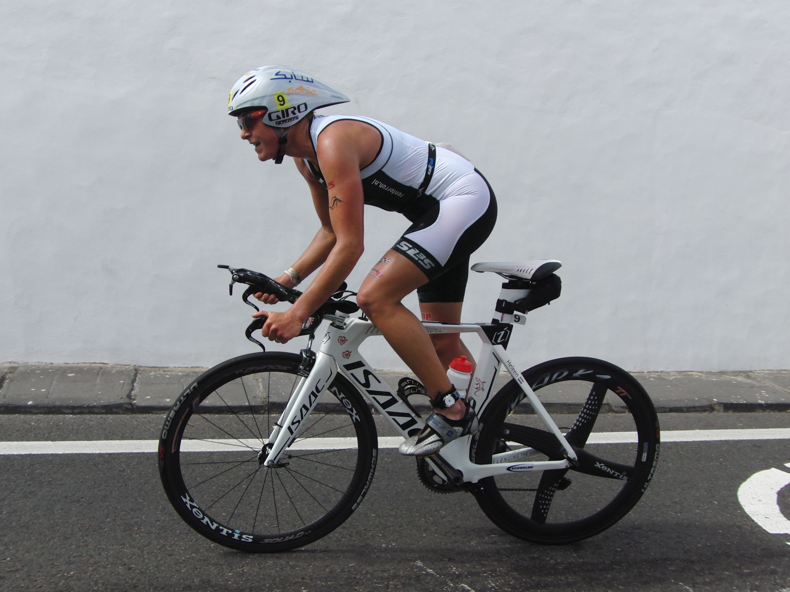
Best bikesplit Ironman Lanzarote

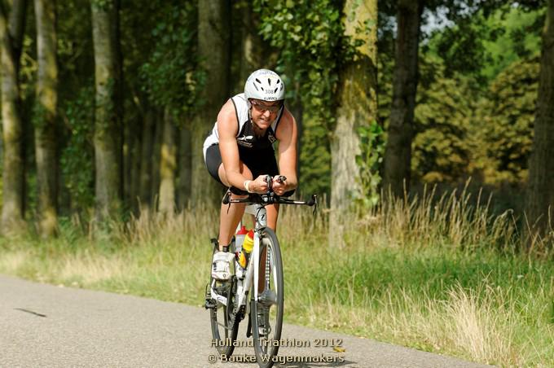
Fast bike split in Almere on the Isaac Muon TT

RESULTATEN 2012

- 1st place Dutch Championships LD Triathlon Almere – The Netherlands
- 3rd place Ironman Lanzarote - Spain
- 3rd place 70.3 Ironman Antwerp – Belgium
- 10th place Ironman Florida – USA
- 7th place 70.3 Ironman South Africa – South Africa
- 8th place Middle Distance Fuerteventura – Spain
- 1st place Intermediate Distance Great Floridian – USA
- 2nd place International Sprint Duathlon Meaux – France

- Ironman New York – USA – DNF
- Half triathlon Stein – The Netherlands - DNF

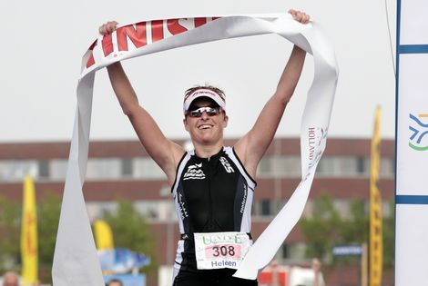

Dutch National Champion Long Distance 2012!

SPONSORS 2012 – Thanks Again !!!

This was my 6th year as a full-PRO triathlete and of course this is only possible because of my fantastic sponsors, all presented on my website www.heleenbijdevaate.nl. Besides my stories on my website, you can also follow me as well on Twitter and Facebook.

Here you can find a small thank you per sponsor:
SABIC Thanks for the support, so I was able to prepare myself in the most
professional way for the races.
Tehava Because you supported me with the Isaac Muon TT bike, I was able to cycle
very fast bike splits. This resulted in the fastest woman bike split on Lanzarote and two times a sub 5-hour on the 180 km in Almere and Florida.
Extreme Endurance Thanks to your products, my recovery after races and hard training
sessions goes much faster. Besides the Vital40 keeps me very healthy!
Sailfish Although I’m not a good swimmer I still feel like a fish in the water with this
G-range wetsuit. Thanks for that.
Schwalbe With these tyres I never have a flat! And besides that they are very fast too!
C-bear With these bearings I ride 2 km/hour faster for free!
Fizik This saddle is still comfortable after 180 km of fast riding.
SLS3 Due to these compression socks the recovery after races is very good. I
wear them always during flights and during hard run sessions.
And the race gear is really cool!
TAO Thanks for the nice and high quality running clothes.
Ronforrun You give me always very professional advice and the right shoes to
run on!
BORN Born final gives me the right energy during the race so I can perform on my
top! And the Born drink and energy keep me going during the training sessions.
Suunto The heart rate monitor from Suunto is my training buddy! Very reliable.

Of course I would like to thank all of these sponsors again for their great support and nice cooperation! I really hope to team up with them for long time in the future to prepare in the most professional way for my races. Let’s hope for a very nice 2013 race season!


