Professional Triathlete Heleen bij de Vaate
Season 2011

“Personal record: Sub 9 hour on the Ironman!”

Dear reader,

This season was one with highs and lows. In January we moved to the northern part of France. My start was for this reason somewhat later then normal. I had 3 goals this year. Finishing under 9 hours in the Ironman of Klagenfurt, to qualify for IM Hawaii and to finish top 10 in Hawaii. I have reached the first 2 goals. Before Hawaii I was even ranked number 8 on the world ranking. Unfortunately, the race itself was a great disappointment. I would like to review this season with you below:

January-April Discovering a new trainings location
In January we moved to France because of Rob’s job. After we were settled it was time to find new training-facilities, a triathlon club, a swim trainer and a physiotherapist. Within a few weeks I found all of them. Compiegne, our new hometown, is a perfect sports city. There are two 25 m pools, a pretty new track and a very big forest. Also the surrounding is a great place to do my rides. Besides that I had to get used to my new home. The last few years I traveled to nice warm places in these months to get a good basis for the new season. This was something different. Luckily I have found fun back and like it here!
In the first few months I did some small races in France to get used to racing again. I ended this period with the National and European Championship Powerman Duatlon in Horst. Unfortunately I wasn’t ready for this race and the result was not good.

May-June Preparation for the first peak: IM Klagenfurt
The month of May was dominated by two half Ironmans. The first one was on the island of Mallorca and I combined it with a training camp before the race. Here I have made a good basis for the season. Still I was not good enough to compete for the prices. Result was an 11th spot. The week after I started in the 70.3 IM St Polten in Austria. In this race I was already a little bit better and I finished 8th female. The goal of these races was to get used to racing for Ironman Klagenfurt. I was very happy with my swim level, this was better then former years. The approach of my new swim trainer in France (he is a former European champion on the 25 km in open water) is working. After 70.3 St. Polten I traveled to Spain for an altitude camp as a last preparation for IM Klagenfurt.

July Two Ironmans in 3 weeks: Klagenfurt and Frankfurt
This year the qualification system for Hawaii (Kona Points Ranking) has changed. This means that you need to collect points to qualify for Hawaii. I will not explain the precise system, but it means that you can count a maximum of 5 races. Also the 70.3 Ironmans have points, but less then the full distance ones. Because of my 9th finish in IM Hawaii last year, I had already my first points. Hawaii is the race where you can get the most points. But with these points you aren’t there yet, besides that you have to finish another IM to start qualify again for Hawaii.
This was the reason for deciding to peak in Ironman Klagenfurt, and to start three weeks after in IM Frankfurt to gather extra points. I knew before hand that it is not possible to peak in two races within three weeks. In Klagenfurt everything went perfect. The swim was great, for the first time within one hour, a PB. Also the bike part went very well and I started the run in 4th place. My goal was to run as fast as possible, hopefully within 3 hours. And I managed to do that with a total time of 8 hours 56 minutes and 12 seconds. A great PB and now I belong to the selective group of women who finished sub 9 hours. Unfortunately the field was very strong and I ended up only in 4th place, a spot besides the podium.
In the mean time I was still ranked high in the KPR, but I didn’t want to risk anything so I decided to start in IM Frankfurt. In this race it was again a very strong field, but my goal was to finish top 10. The swim and run were reasonable, but during the bike part I could feel that I did another IM 3 weeks before. Still a 9th place and the qualification for Hawaii was secured! My final position in the KPR was 8th.

August-September Preparation second peak of the season: IM Hawaii

After IM Frankfurt I have taken a little bit of rest to recover from the season so far. The second week of August the preparation towards Hawaii started. At the end of this month the first test was already planned: the half Ironman distance of Cambrai just close to our new hometown in France. This race was meant as training race; swim and bike full power and the first 10 km of the run part some speed and the rest easy. I rode my new bike for the first time during a race: the Isaac Muon TT. A very fast bike, but my legs were too tired. The result was a second place. I knew that I had to work hard in the next couple of weeks to got well prepared for Hawaii. The week after I started in the half Ironman distance of Gerardmer. A famous race in France that I always had wanted to do. Again I got confronted with the fact that I’m not made for hilly courses. Finally I finished as 5th woman. Directly after the race I flew to the Sierra Nevada in Spain for a trainingcamp. The temperatures were perfect, good heat acclimation for Hawaii, and of course the altitude training. I started to feel stronger and bit-by-bit I got more self-confidence for Hawaii.

October WC Ironman Hawaii

Just as last year we arrived two weeks before the race on Hawaii. A good way to get rid of my jetlag and to acclimatize. The days before the race went perfect, but for a certain reason I did not have the confidence that I had last year before the race. On October 8 it had to happen and my goal was good race for myself, and a top 10 finish in the women field. Unfortunately it went already wrong during the swim. I knew that when I got the right feet everything was possible. But I missed these feet and I had to swim all by myself. With a swim time which was my worst in this race ever, I got out of the water. At this moment I did not give up. But when I started biking I felt that it was not going to be my day. The first 30 km I tried really hard, but it was not good enough. An Ironman is very long and the race is determined 50 % mentally and 50 % physically. This time I lost the mental game. As soon as I got of my bike I had only one goal and that was to cross the finish line. I’m proud of my self because I did not give up, but also I’m very disappointed about the result. I learned a lot in this race and I can take it with me in coming races.

November-December The start of a new season: 2012
Hawaii was my last race. The reason for this is that I want to start my competition early in 2012. The first race will be IM 70.3 South-Africa. I started my preparation for 2012 in November. In December I will go to Lanzarote for 12 days to work on my cycling. I’m very motivated and I want to make a top year of 2012!

The sport-year 2011 was a very strange one for me. I didn’t reach my top level a lot, but the time I did it in IM Klagenfurt, it was really good with a PB below 9 hours. This gives me the confidence that I can still improve. My goal for 2012 is therefore to perform more constantly and to improve again, so I can reach a higher level.

Sports Greetings,
Heleen.
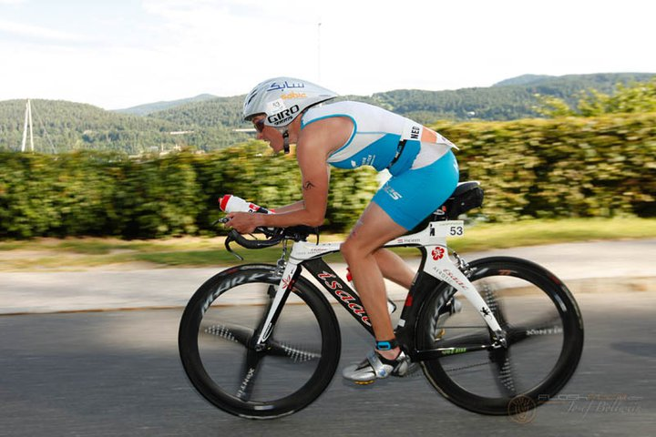
Personal best 8:56:12 in Ironman Austria!

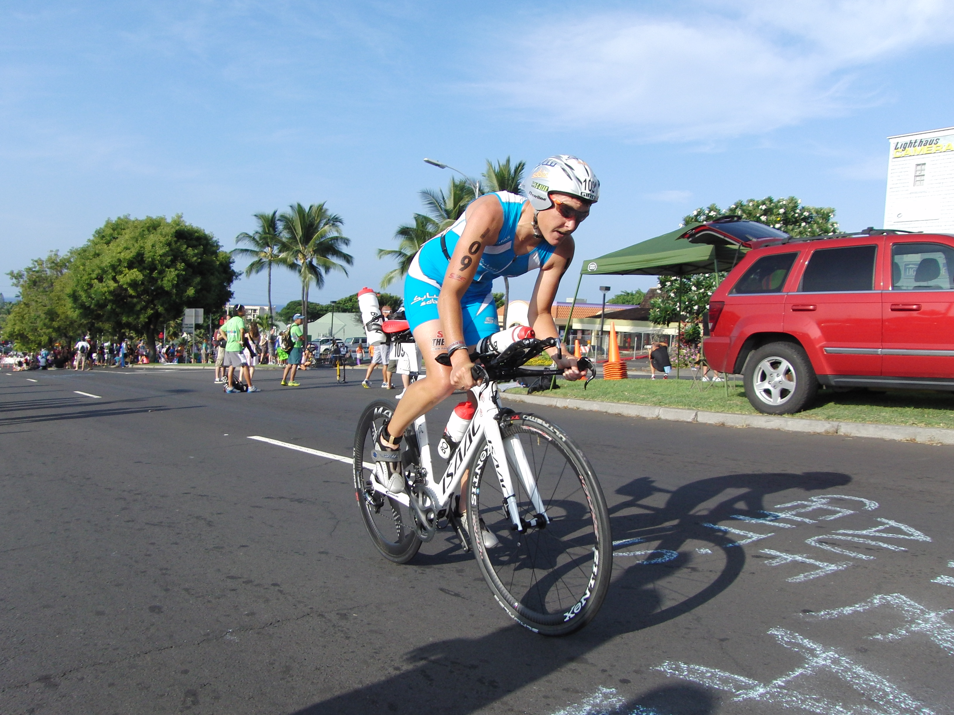
4th finish in Ironman Hawaii on new Isaac Muon TT

RESULTS 2011

- 4th place Ironman Austria - Austria
- 9th place EC Ironman Germany - Germany
- 8th place 70.3 Ironman Austria – Austria
- 11th place 70.3 Ironman Mallorca – Spain
- 2nd place Cambrai – France
- 5th place Middle Distance Gerardmer – France
- 24th place WC Ironman Hawaii – USA
- 16th place EC Powerman Horst a/d Maas – The Netherlands

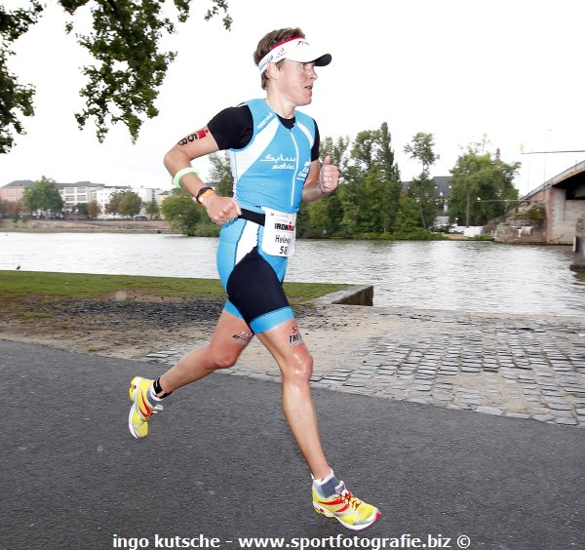

Halfway the run-course in the Ironman European Championships in Frankfurt:

3rd fastest woman Marathon-split time

SPONSORS in 2011 – Many thanks again !!!

This was my 5th year as a full PRO and of course this is only possible because of my fantastic sponsors. On my website www.heleenbijdevaate.nl we have plenty of possibilities to show all of them and their products. Besides my stories on my website, you can also follow me as well on Twitter and Facebook.

As in previous years, my main sponsor in 2011 was again SABIC. I also signed a new sponsor contract with Tehava. Tehava provides me with their new time trial bike, the Isaac Muon TT. In the last races of the season I rode this very fast bike.

Further, my thanks go to all my other sponsors (see below), who care for all my gear and other products you need to keep on improving as a pro triathlete. The fact that also they are constantly working on developing their products give me a good feeling while at the starting line: on them I can trust.

Of course I would like to thank all of these sponsors again for their great support and nice cooperation! I really hope to team up with them for long time in the future to prepare in the most professional way for my races. Let’s hope for a very nice 2012 race season!









All-Time World-ranking Woman sub-9hours on Ironman distance (only PB per person)
 | Name & nationality | Year & race | Time & splits
1 | Chrissie Wellington | 2011 | 8:18:13
1 | (GBR) | Roth (GER) | (0:49:49 - 4:40:39 - 2:44:35)
2 | Rebekah Keat | 2009 | 8:39:24
2 | (AUS) | Roth (GER) | (0:50:21 - 4:50:10 - 2:55:27)
3 | Mary Beth Ellis | 2011 | 8:43:34
3 | (USA) | IM Klagenfurt (AUT) | (0:48:07 - 4:48:10 - 3:01:29)
4 | Yvonne van Vlerken | 2008 | 8:45:48
4 | (NED) | Roth (GER) | (0:53:47 - 4:54:11 - 2:54:22)
5 | Erika Csomor | 2008 | 8:47:05
5 | (HUN) | Roth (GER) | (0:53:37 - 4:54:10 - 2:55:54)
6 | Sandra Wallenhorst | 2008 | 8:47:25
6 | (GER) | IM Klagenfurt (AUT) | (0:57:19 - 4:50:43 - 2:54:44)
7 | Catriona Morrison | 2009 | 8:48:11
7 | (GBR) | Roth (GER) | (0:51:46 - 4:48:55 - 3:03:57)
8 | Leanda Cave | 2011 | 8:49:00
8 | (GBR) | IM Tempe (USA) | (0:52:08 - 4:51:06 - 2:58:51)
9 | Bella Bayliss | 2009 | 8:50:13
9 | (GBR) | IM Klagenfurt (AUT) | (0:54:04 - 4:49:42 - 3:00:21)
10 | Paula Newby-Fraser | 1994 | 8:50:53
10 | (ZIM) | IM Roth (GER) | (0:50:55 - 4:49:48 - 3:10:10)
11 | Lori Bowden | 2002 | 8:51:22
11 | (CAN) | IM Klagenfurt (AUT) | (0:55:46 - 4:50:58 - 2:59:55)
12 | Riana Riesler | 2011 | 8:53:34
12 | (AUT) | IM Klagenfurt (AUT) | (0:58:20 - 4:43:50 - 3:05:41)
13 | Kate Allen | 2003 | 8:54:01
13 | (AUT) | IM Klagenfurt (AUT) | (0:49:14 - 5:03:28 - 2:57:12)
14 | Linsey Corbin | 2011 | 8:54:33
14 | (USA) | IM Tempe (USA) | (0:57:00 - 4:50:11 - 3:02:27)
15 | Jessica Jacobs | 2011 | 8:55:10
15 | (USA) | IM Florida (USA) | (1:02:03 - 4:53:42 - 2:53:26)
16 | Thea Sybesma | 1991 | 8:55:29
16 | (NED) | IM Roth (GER) | (0:55:01 - 4:46:22 - 3:14:06)
17 | Ines Estedt | 1995 | 8:56:05
17 | (GER) | Jümme (GER) | (0:50:32 - 5:03:47 - 3:01:46)
18 | Heleen bij de Vaate | 2011 | 8:56:11
18 | (NED) | IM Klagenfurt (AUT) | (0:58:54 - 4:52:16 - 2:59:14)
19 | Irma Heeren | 1999 | 8:56:23
19 | (NED) | Almere (NED) | (1:00:48 - 4:59:47 - 2:55:48)
20 | Julia Wagner | 2011 | 8:56:23
20 | (GER) | Roth (GER) | (0:51:28 - 4:54:27 - 3:07:25)
21 | Katinka Wiltenburg | 1996 | 8:56:57
21 | (NED) | Almere (NED) | (0:55:29 - 5:00:39 - 3:00:29)
22 | Gina Ferguson | 2008 | 8:57:18
22 | (NZL) | Roth (GER) | (0:48:52 - 5:01:42 - 3:03:08)
23 | Mirinda Carfrae | 2011 | 8:57:57
23 | (AUS) | IM Hawaii (USA) | (00:57:17 - 5:04:16 - 2:52:09)
24 | Belinda Granger | 2008 | 8:58:08
24 | (AUS) | Roth (GER) | (0:48:49 - 4:50:24 - 3:15:10)
25 | Joanna Lawn | 2007 | 8:58:25
25 | (NZL) | Roth (GER) | (0:51:46 - 4:52:48 - 3:10:48)
26 | Nina Kraft | 2004 | 8:58:37
26 | (GER) | IM Frankfurt (GER) | (0:48:35 - 5:05:12 - 3:00:54)
27 | Sue Latshaw | 1997 | 8:59:31
27 | (USA) | IM Roth (GER) | (0:52:44 - 4:55:52 - 3:10:55)
28 | Edith Niederfriniger | 2008 | 8:59:43
28 | (ITA) | IM Klagenfurt (AUT) | (0:49:05 - 5:04:17 - 3:01:14)
29 | Sonja Tajsich | 2009 | 8:59:45
29 | (GER) | IM Klagenfurt (AUT) | (0:56:32 - 4:49:06 - 3:09:05)
30 | Krista Whelan | 1992 | 9:00:00
30 | (USA) | IM Roth (GER) | (1:02:24 - 4:38:35 - 3:19:01)

