Professional Triathlete Heleen bij de Vaate
Season 2010

“Top-10 Hawaii reached!”

Dear reader,
This season was marked by returning to top level after one year of injuries. In the beginning it was clearly noticeable that there was still a lot of work to do to achieve this. In the end I managed to make a nice comeback, highlighted by making a top 10 finish in Hawaii, a second place in the Ironman Switzerland and becoming the Dutch Champion in the long distance triathlon in Stein. I would like to review this season with you below:
January-March Abroad: South Africa, Lanzarote, Abu-Dhabi
In January finally I was back at the starting line of a triathlon. Because of the injury year last season, my last triathlon was in July 2009. Now I was injury-free but not yet at the level I wanted to be. The result was a seventh place in the Ironman 70.3 East London, South Africa. To catch up with the lack of training during the cold Dutch winter, I stayed another three weeks in South Africa after the race. Here I started with a foundation for the rest of the season. Almost directly after this trip, I traveled to the next training camp in Lanzarote. Because of the injuries last year this time we were still careful with long running sessions. On March 13 was the next race on the calendar, the triathlon of Abu Dhabi. To acclimatize to the specific weather conditions, I trained in Al-Ain in the United Arab Emirates for one week. The race was a 3 km swim, 200 km cycling and 20 km run. This distance was a good formula for building up to an Ironman. There was a world-class top field at the start and I could not really compete with the best. But it was good to do a long race. The result was a 17th place.
April Duatlon preparation for NC / EC Powerman Duathlon Horst
My month of April was dominated by the National Championships / Powerman Duathlon Championships in Horst. The first preparatory race was the 10 km Parelloop Brunssum at the end of March. The first sign that I came back in better shape was the win on the Sprint Duathlon Dordrecht two weeks later. Not really an important race, but both the running and cycling went very well and I even managed to beat Dutch duathlon champion Ruth van der Meijden.
A week before the Powerman in Horst, the first edition of the triathlon in Weert was held. I thought the time to Horst was too short to compete in the full race. But I got a request of the organization to participate in a trio team, which is a good speed training for a 40km time trial. Again I had very good legs and I rode with an average of 39.9 km / h, a personal best.
In the Powerman Horst the first run went fine, I had limited the gap with the first ladies and was ready to push on the bike. Unfortunately this succeeded only partially, I came off the bike in second, but this was insufficient to get the national title. I was second in the National Championships by being only 13 seconds behind, finishing just aside of the podium as fourth in the European Championships. Given the shape of the previous week, I was not happy with it. The real comeback this season yet had to come.
May-June Altitude camp Spain, NC Nieuwkoop and SABIC Triathlon Stein
In preparation for the Nationals long distance triathlon in Stein, I went on altitude training camp to the Sierra Nevada in Spain in May. There were also some pro-riders from teams like Rabobank and Lotto who were preparing for the Tour de France. This training camp was meant to be a good basis for the races that really matter this summer.
Six days after returning I took part in the national championships middle distance triathlon in Nieuwkoop. Unlike the NC Horst, I had already assumed that I would not win. It was a training race for me. Actually a few years ago I decided that I would never start again in Nieuwkoop, because they do not use the real middle distance, but a distance with prolonged swimming and less cycling. Both disadvantages for me. Mirjam Weerd took advantage with 10 minutes lead on me after the swim, but I managed to reduce this gap by more than 5 min during the bike section and another few minutes during the run. Still I came over 2 minutes too short for the title, but I was satisfied with a good preparation race for Stein and again on a silver NC medal.
I would love to win the NC long distance Stein and to get my course record back. But first I had to deal with the number 4 of Hawaii 2009, the Czech Tereza Macel. Together with Sonja Jaarsveld and Eva Janssen it was the most exciting edition of Stein so far. In a nice race I rode the fastest bike time ever ridden on this course and we were all four close together when we started the run. It resulted in a win, a NC-title, a course record and a lot of confidence that I was back again!
July Ironman Switzerland, Zurich
The next mission was completing a full distance triathlon. Five weeks after Stein, I was ready to start in the Ironman of Switzerland. My last IM was the Ironman Arizona in November 2008 which I won, so one and a half years ago. Now I would like to join the podium again and hopefully I could qualify for Hawaii. The swim went well, the bike part was reasonable (not the super form of Stein on the bike) and the running leg was of quite a good level. I ran a 3.07 marathon which was the same time I did in Arizona, so I proved myself that I could really still do it. With the second place and a very good feeling of the Hawaii qualification in the pocket, I went home for a week of recovery and then started to work for the race on October 9.
August-October Hawaii Ironman World Championship and Preparation
In summertime, training in the Netherlands is excellent, so in August I started the training at home and in the Flevopolder. There was a minor setback of a small pain in my legs so I didn’t run for two weeks and had to cancel a race in Veenendaal. But in September I was ready for the half-triathlon in Cologne, the final preparation race for Hawaii. It went well, I could feel that the fatigue of the Ironman was out of my body and the cycling part was “going like a train”, as we say in Dutch. The race itself was too busy on a course which was too tight, so it was a drama with big drafting groups. Unfortunately I got my first penalty in my career. So I had to wait for a few minutes in the penalty box before I could start running. The running itself was also very reasonable, but the podium remained out of reach.
The next day we traveled straight to the second training camp in the Sierra Nevada. The temperatures were perfect, good heat acclimation for Hawaii, and of course the altitude training. I was strong enough to do pretty heavy training and paying a lot of attention to the recovery part, I could hold it the entire training camp. Then I went to Hawaii, where the last two weeks the training was also great and I felt perfect during the last week of tapering towards the race. I felt like I was never as strong as I was now, but the question is if you are able to show it on raceday. Luckily the race exactly went according to plan. Unfortunately the swim was a little less, but the cycling and running were great. The goal top-10 finish in Hawaii has been reached!
October-November Ironman Arizona
Starting this year, a new qualification system for the 2011 Hawaii Ironman will apply. This means that there are points to be collected for the world ranking to qualify. It counts a maximum of 5 races, including Hawaii 2010, which was my first. Furthermore, only the 30 women with the most points will start in Hawaii. That’s the reason I decided to start six weeks later in the Ironman Arizona. This meant two weeks of recovery after Hawaii, two weeks training in the Netherlands, one week training in Arizona and then one easy week to prepare for the third Ironman this year. Basically I had nothing to lose, Hawaii was super, and I was curious how well I could keep up with my form. The two weeks training in the Netherlands were not easy because of the weather. And because of the new qualifying system, there were many girls who had the same ideas which I had. This resulted in the second strongest starting field for an Ironman this year (Hawaii the strongest one). For me it was a decent race. I did not have the form of Hawaii anymore, but still I finished just within the 9 ½ hours as eighth lady. With enough points to finish 2010 as ninth in the world ranking. This was the last race of a nice comeback season, what I may actually call a great year!
Sports Greetings,
Heleen.

RESULTS 2010

- 9th place World Championships Ironman Hawaii - USA
- 2nd place Ironman Switzerland - Switzerland
- 1st place Dutch Championships Long Distance Stein – The Netherlands
- 2nd place Dutch Championships Middle Distance Nieuwkoop – The Netherlands
- 2nd place Dutch Championships Powerman Duathlon Horst – The Netherlands
- 8th place Ironman Arizona – USA
- 4th place Middle Distance Koln – Germany
- 17th place Abu Dhabi Triathlon – United Arabic Emirates
- 7th place 70.3 East London – South Africa
- 1st place Sprint Duathlon Dordrecht – The Netherlands

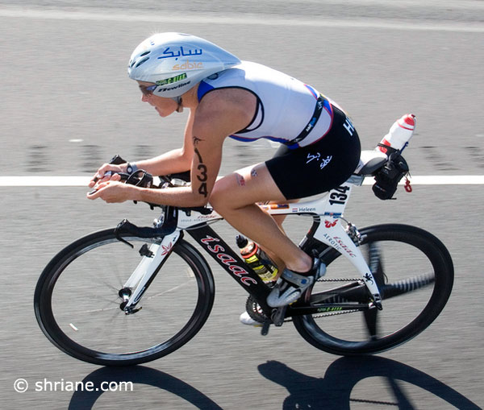

Halfway the bike-course in the Ironman World Championships in Hawaii

SPONSORS in 2010 –Many thanks again!!!

This was my 4th year as a full PRO and of course this is only possible because of my fantastic sponsors. On my website www.heleenbijdevaate.nl we have plenty of possibilities to show all of them and their products. The amount of visitors of my website is still growing (about 25 hits a day, this is over 10.000 a year), and you can follow me as well on Twitter and Facebook. Next to that, there were several nice articles and interviews in the press.

As in previous years, my main sponsor in 2010 was SABIC. This fall we signed a contract for another 2 years, so SABIC will be my main sponsor up and until 2012. Many thanks to them!

Further, my thanks go to all my other sponsors (see below), who care for all my gear and other products you need to keep on improving as a pro triathlete. The fact that also they are constantly working on developing their products give me a safe secure feeling while at the starting line: on them I can trust.

A new sponsor since the end of this year is SLS3, sponsoring me with compression clothing. And in the near future you will see some announcements about my new tri-bike for 2011. It will be a renewed cooperation with my bike sponsor for years, Isaac, who have a brand new engineered tri-bike available soon.

Of course I would like to thank all of these sponsors again for their great support and nice cooperation! I really hope to team up with them for long time in the future to prepare in the most professional way for my races. Let’s hope for a very nice 2011 race season!



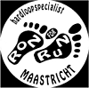



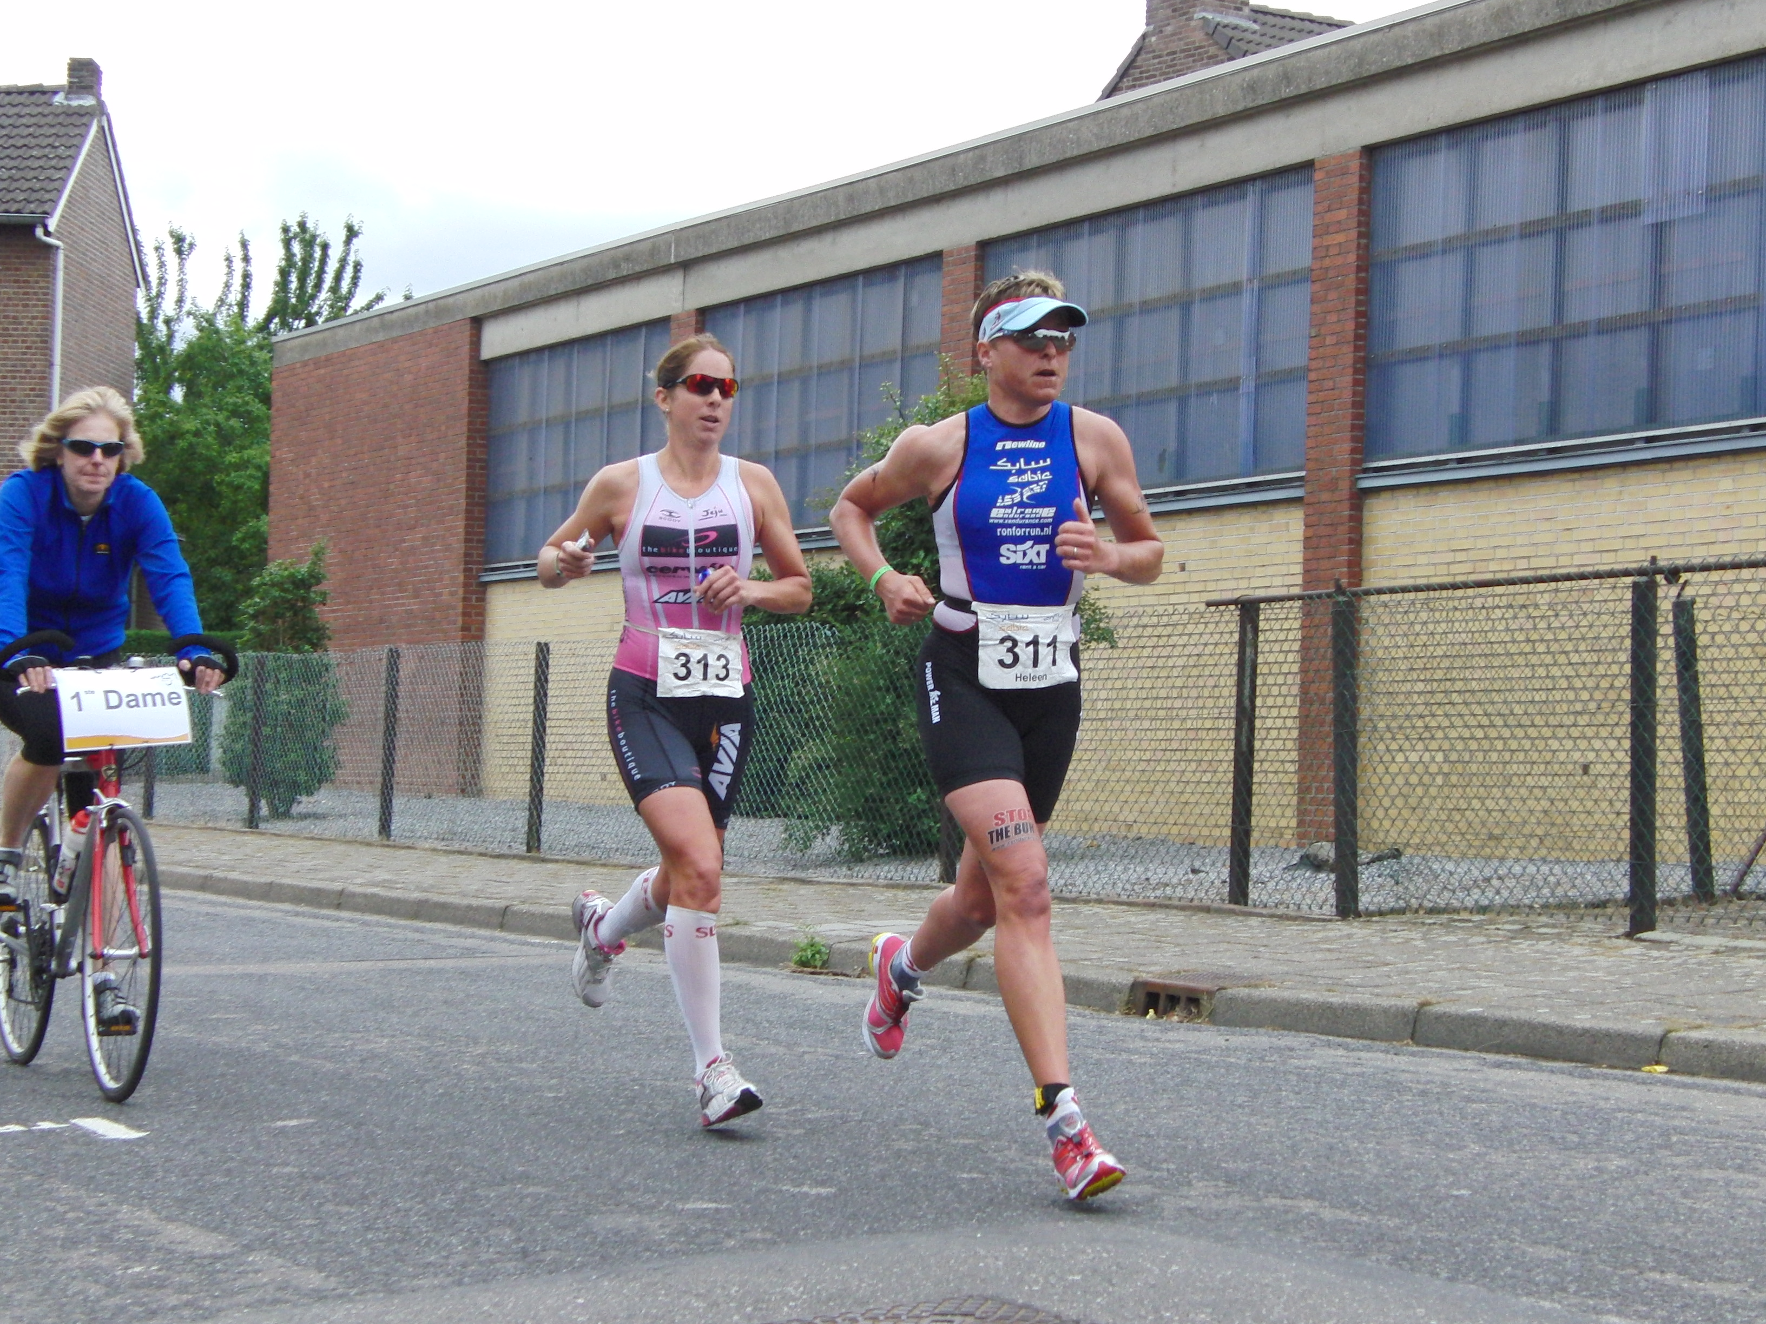

Open Dutch Championships title Long Distance Triathlon in hometown Stein

